Experiment 9
Create a Scrum Project in Jira.
• Add a backlog with at least 5 items (e.g., &quot;Create user
registration page&quot;, &quot;Develop API for login&quot;).
• Prioritize the backlog and create a 1-week sprint.
• Move backlog items into the sprint and start the sprint.
• Finally show the Screenshot of the sprint board at the start and
end of the sprint.
Step 1: open jira
Step 2:
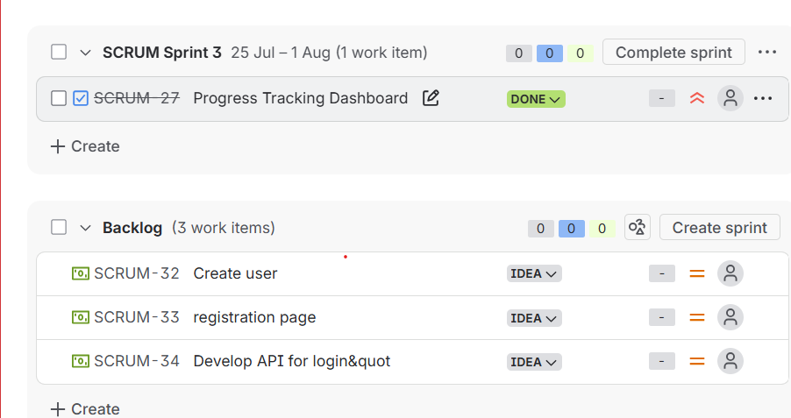

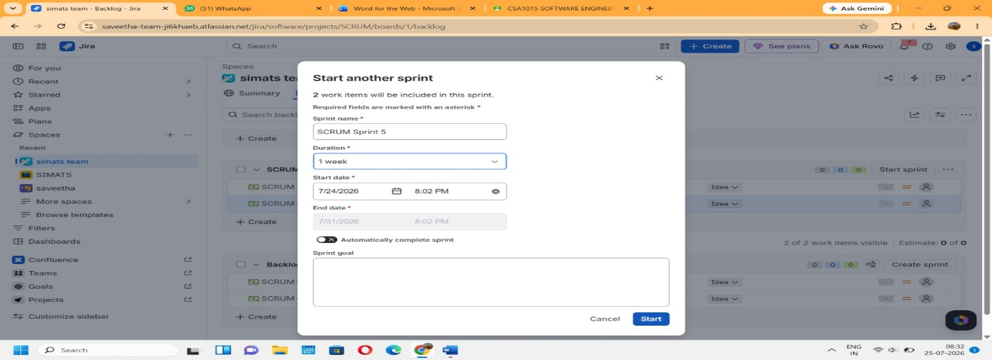
Step 3:

Step 4:
